**Mid Term Examination 2022-23**

**Govt. Co-ed Sec School, Vipin garden (School id -1618316)**

**Subject- Computer (ICT) [Time=1 hour]**

**NAME- Student ID- [Maximum marks-20]**

**Roll Number- Day and Date- Class and Sec-**

**------------------------------------------------------------------------------------------------------------------------------------------------------------------------------------**

1. **Identify the following hardware as “INPUT device” or “OUTPUT device”. [5*1=5]**  
   a. Monitor __________________________________  
   b. Keyboard __________________________________  
   c. Scanner __________________________________  
   d. Printer __________________________________  
   e. Mouse __________________________________

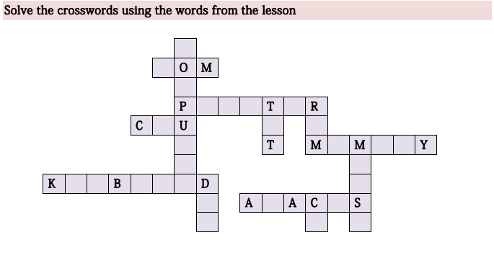

1. **Write the name of each Hardware of the below Computer System in the Bubble. [5 *1 = 5 ]**

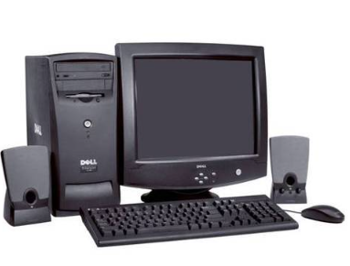

1. **Write the answer of the following questions- [2*2 =4]**
2. **Write down 2 uses of Computer?**

**--------------------------------------------------------------------------------------------------------------------------------------------------------------**

**---------------------------------------------------------------------------------------------------------------------------------------------------------------**

**----------------------------------------------------------------------------------------------------------------------------------------------------------------**

**---------------------------------------------------------------------------------------------------------------------------------------------------------------**

1. **What is the use of Storage device and how many types of storage device?**

**----------------------------------------------------------------------------------------------------------------------------------------------------------------**

**---------------------------------------------------------------------------------------------------------------------------------------------------------------**

**----------------------------------------------------------------------------------------------------------------------------------------------------------------**

**---------------------------------------------------------------------------------------------------------------------------------------------------------------**

**----------------------------------------------------------------------------------------------------------------------------------------------------------------**

**---------------------------------------------------------------------------------------------------------------------------------------------------------------**

**OR [4*1=4]**

**Write “True” or “False” for the following statements:-**

1. **CPU process the input instruction. [ ]**
2. **Byte is the smallest memory measurement unit. [ ]**
3. **Laptop is hard to handle than Desktop Computer. [ ]**
4. **HP, LENOVO, ACER and DELL are the famous brand of laptop. [ ]**